# Message July 16, 2018

Dear Advisory Board,

Lauren and Jenna met up with collaborators at the [Zine Librarians UnConference](http://zinelibraries.info/wiki/zluc-2018-msp/), where we facilitated three Zine Union Catalog sessions (with links to session notes)

[ZineCat Update](https://docs.google.com/document/d/1QQinQoicxS_OZqfxaXPSLSSq0bY7GKwnSpQnUganOUw/edit#heading=h.7aw2n7hqwyr9)

[Decision-Making](https://docs.google.com/document/d/1QQinQoicxS_OZqfxaXPSLSSq0bY7GKwnSpQnUganOUw/edit#heading=h.ywdk6ka4cnke)

[Project Hack](https://docs.google.com/document/d/1QQinQoicxS_OZqfxaXPSLSSq0bY7GKwnSpQnUganOUw/edit#heading=h.ljzjmzie5uid)

* Grants and Decision-Making with Lauren and Jennifer (Austin Fanzine Project)
* Library record ingests with Eric (ABC No Rio), Milo (QZAP), Hedge (zine maker), Ella (RIT), Kelly S. (MICA) and Jenna
* Accessibility and WikiData with Kat (librarian and zine maker), Elissah (MCTC), Honor (Harvard), and Violet (roving zine librarian and zine maker)

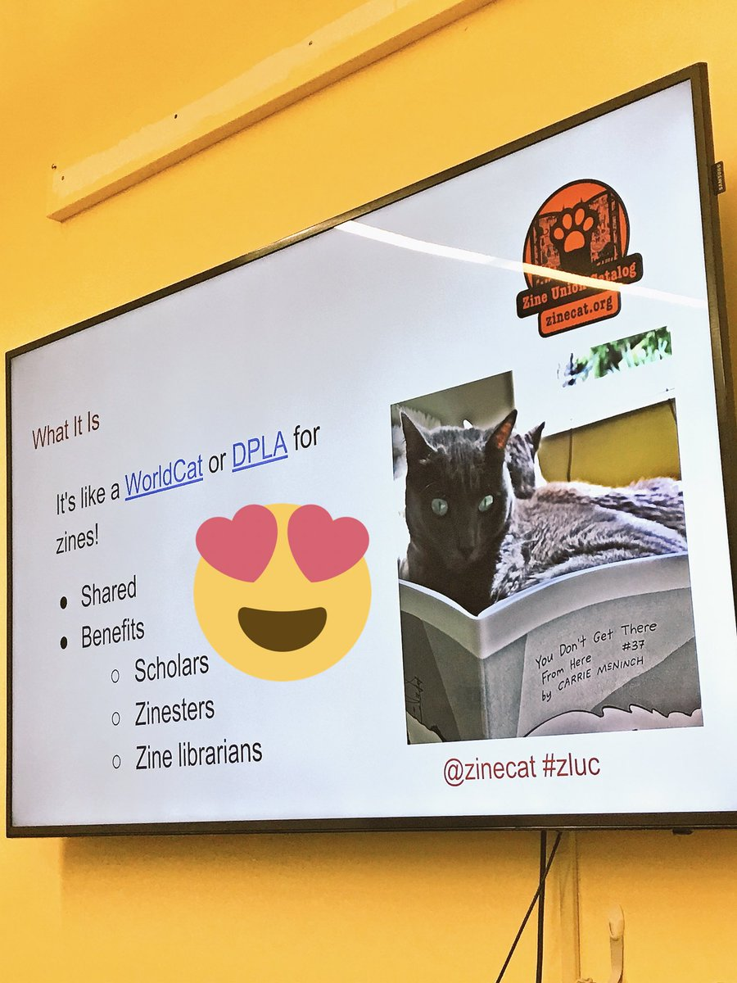

Photo from a [Tweet by Ziba Zehdar](https://twitter.com/iLuvLibraries/status/1017813609592840197)

In general attending and leading discussions about ZUC at ZLuC helped us reinvigorate people already involved in the project and attract new collaborators, as well as connect Lauren face-to-face with other ZUC project partners for the first time. (Lauren was really happy to meet everyone in person!!)

## A few specific takeaways

### ZineCat Update

* Lots of talk about harmonizing metadata, including [SNAC](https://snaccooperative.org), [Western Name Authority Project](https://sites.google.com/site/westernnameauthorityfile/), [ISNI](https://wiki.duraspace.org/display/PCCISNI/PCC+ISNI+Pilot+Home), whether the old name authority model is even worth pursuing
* Priorities for adding sample library records to the catalog: new-to-us-ness (no library in the catalog yet using the same schema), applicability to other libraries (e.g., a library that uses LibraryThing that can stand in for all LT zine libraries), enthusiasm (Ziba).
* We ended with a go-around of participants priorities for the catalog
  + Build in consent/challenging processes
  + Add dark archive functionality--embargo data for time period
  + Outreach (+3)
    - to POC zine creators
    - at zine fests, develop a presentation template
  + Accessibility (+1)
  + Fundraising
  + Sustainability (+1)
  + Searchability
  + Documentation and transparency
  + Ingest models
  + Visual resources
  + Project management tools

### Decision-Making Discussion

Lauren and Jennifer (who organized the [notes at an earlier decision-making process meeting](https://docs.google.com/document/d/e/2PACX-1vTyqg3SR1b4UAlnRTfvotDvO05HD8tFD9v9QBHNPfi3WAMRA8tZfuptGbTt3OZBPY7OajlbrSv5DTXw/pub) that were used as a basis of this discussion) co-facilitated. The session was live-streamed, and we believe will be published at some point. We'll share that link as soon as we have it.

The proposal, linked above, is open for comments and edits. Please contribute your thoughts and feelings. In general, people seemed enthusiastic, but acknowledged there is still work to be done, especially because the decision-making process is currently designed for member libraries, when currently there are no members, exactly. It was agreed that an Advisory Board is integral to ZineCat’s ongoing development and several ZLuC attendees were enthusiastic about forming a “cheer squad” to support the project’s development. We reiterated that in addition to deciding how decisions should be made, we need to institute a project management tool, perhaps RedMine.

### Group Hack

Grants Group: brainstormed grants for the whole project, as well as smaller grants for pieces of the project.

Ingest Group: we spent a good amount of time on setting up accounts, so there was no actual ingest. Instead, it was something of an orientation to CollectiveAccess.

Disability/Accessibility Group: assembled a list of resources, things to focus on. There is also a [Zotero Library](https://www.zotero.org/groups/274856/fast_zine_horse) that has useful resources.

Here are @zinecat-related [tweets](https://twitter.com/search?f=tweets&vertical=default&q=%23zluc%20%40zinecat&src=typd) from the conference. Up next: notes from the post-ZLuC hack at the Queer Zine Archive Project in Milwaukee.

# ???

Dear Advisory Board,

We're in the home stretch! Our [final presentation](http://blog.zinecat.org/updates/zine-union-catalog-showcase-presentation/) is on Wednesday. [Please come](https://gcdi.commons.gc.cuny.edu/2017/05/10/the-digital-gc-2016-2017-year-end-showcase) if you're around, and if you're not, **email me your postal address**, and I'll send you a copy of our final zine (cover below), a couple of logo stickers, and a xZINECOREx button.

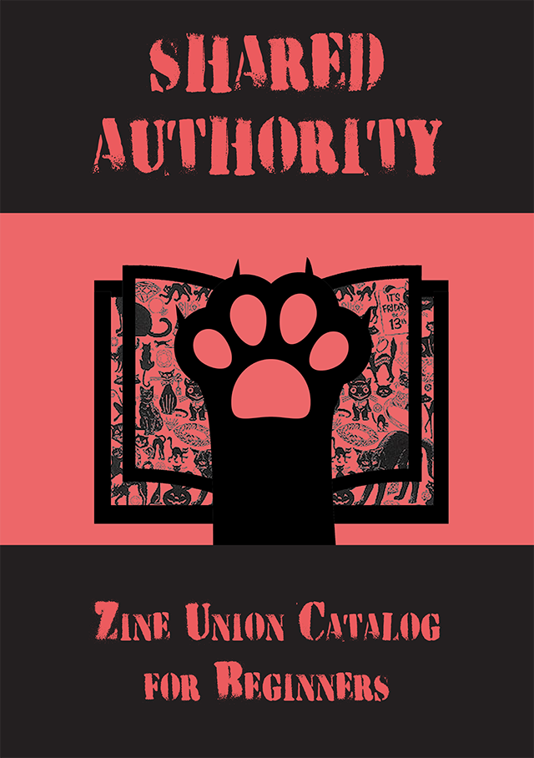

Our holdings and configurations are now on our [live website](http://browse.zinecat.org/), which the CUNY Graduate Center funded for a year. The project will continue with the CUNY GC ZineCat team uniting with the [Zine Librarians Zine Union Catalog working group](http://zinelibraries.info/category/cataloging/union-catalog/). Would you like to remain on our advisory board going forward? **Please let me know: you have to affirm your continuing interest**, otherwise, you're off the hook.

Either way, thanks so much for your support this semester!

With relief and pride,

Jenna and the rest of the [ZineCat team](http://browse.zinecat.org/index.php/About/Index): Alex, Lauren, and Martí

# Message May 7, 2017

Dear Advisors,

We continue to make progress, informed by your feedback, mostly on a development site: <http://test.zinecat.org>. We've added zine library logos to our home page (looks bad in Chrome), uploaded records from each of those three libraries, brought in date and publication data, and a link back to the source catalog, so you can find out more about the zine(s) you're interested in.

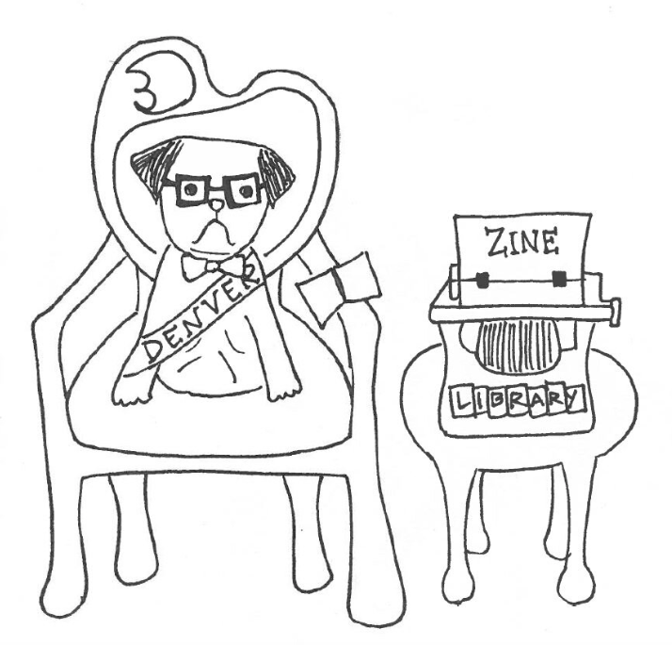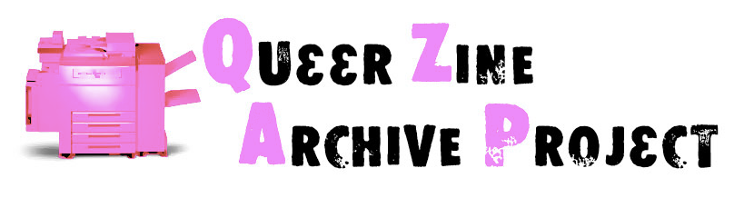

Will you have a look at our dev site and share your reactions, advice, and questions?

The records still don't look very pretty, but functional seems like a huge step. :) We'll update the main site on Saturday in anticipation of our [public presentation](https://gcdi.commons.gc.cuny.edu/event/the-digital-gc-2016-17-year-end-showcase/) on Wednesday, May 17 at 4:15 at the CUNY Graduate Center, to which you are invited. Dress: casual. Bring: vegan pastries and venture capitalists nostalgic for their punk days of yore.

With undying affection,

Jenna and the rest of the [ZineCat team](http://browse.zinecat.org/index.php/About/Index): Alex, Lauren, and Martí

# Message April 22 or 23, 2017

Dear Advisors,

We are soooo far from where we hope to be, come presentation day on May 17th. If we find we aren't able to accomplish everything we want to, we need to determine our priorities, and for that, we are finally asking you for advice worthy of our advisory board. Have a look: <http://browse.zinecat.org>

Will you rank these to-dos, on or off list, with or without annotation?

* Create user account
* Develop user roles: cataloger, researcher, administrator
* Browse all objects from the home page
* Metadata beyond author/title
* Improve functionality and appearance of individual records
  + Get rid of empty images
  + Add clickable fields
  + Link records to source catalog
* Landing page design inviting and informative

In other news, we've named our zine-alogue raisonné. It will be called *Shared Authority: Zine Union Catalog for Beginners*. Or maybe we'll reverse that. At any rate, we're looking to anarchist posters for design inspiration. Our logo is already black and red. Expect to see more.

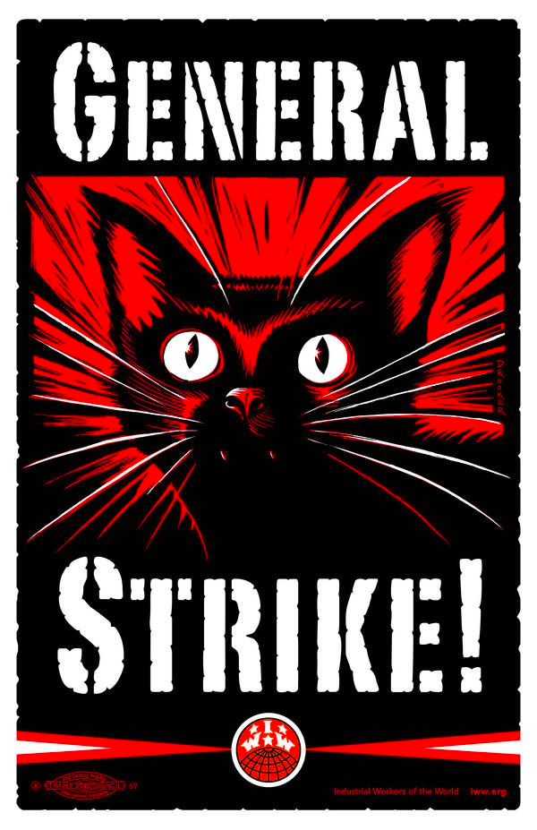

As always, thank you for your help!

With gratitude and devotion,

Jenna and the rest of the [ZineCat team](http://browse.zinecat.org/index.php/About/Index): Alex, Lauren, and Martí

# Message April 15, 2017

Dear Advisors,

Spring break week is coming to an end, and now things are about to get *serious*. We're thinking about our final presentation and making a zine to accompany it (of course). For those of you in the NYC area, we'd love to have you attend the showcase. It's Wednesday, May 17 4:15-6:15 at the CUNY Grad Center. Whether you can make it or not, please [recommend songs for the zine playlist](https://docs.google.com/forms/d/e/1FAIpQLSfwk4BpN_p3IsGuSzjexaTzHM3_Pm5XqA-wIhmKFZQq7_9H6w/viewform).

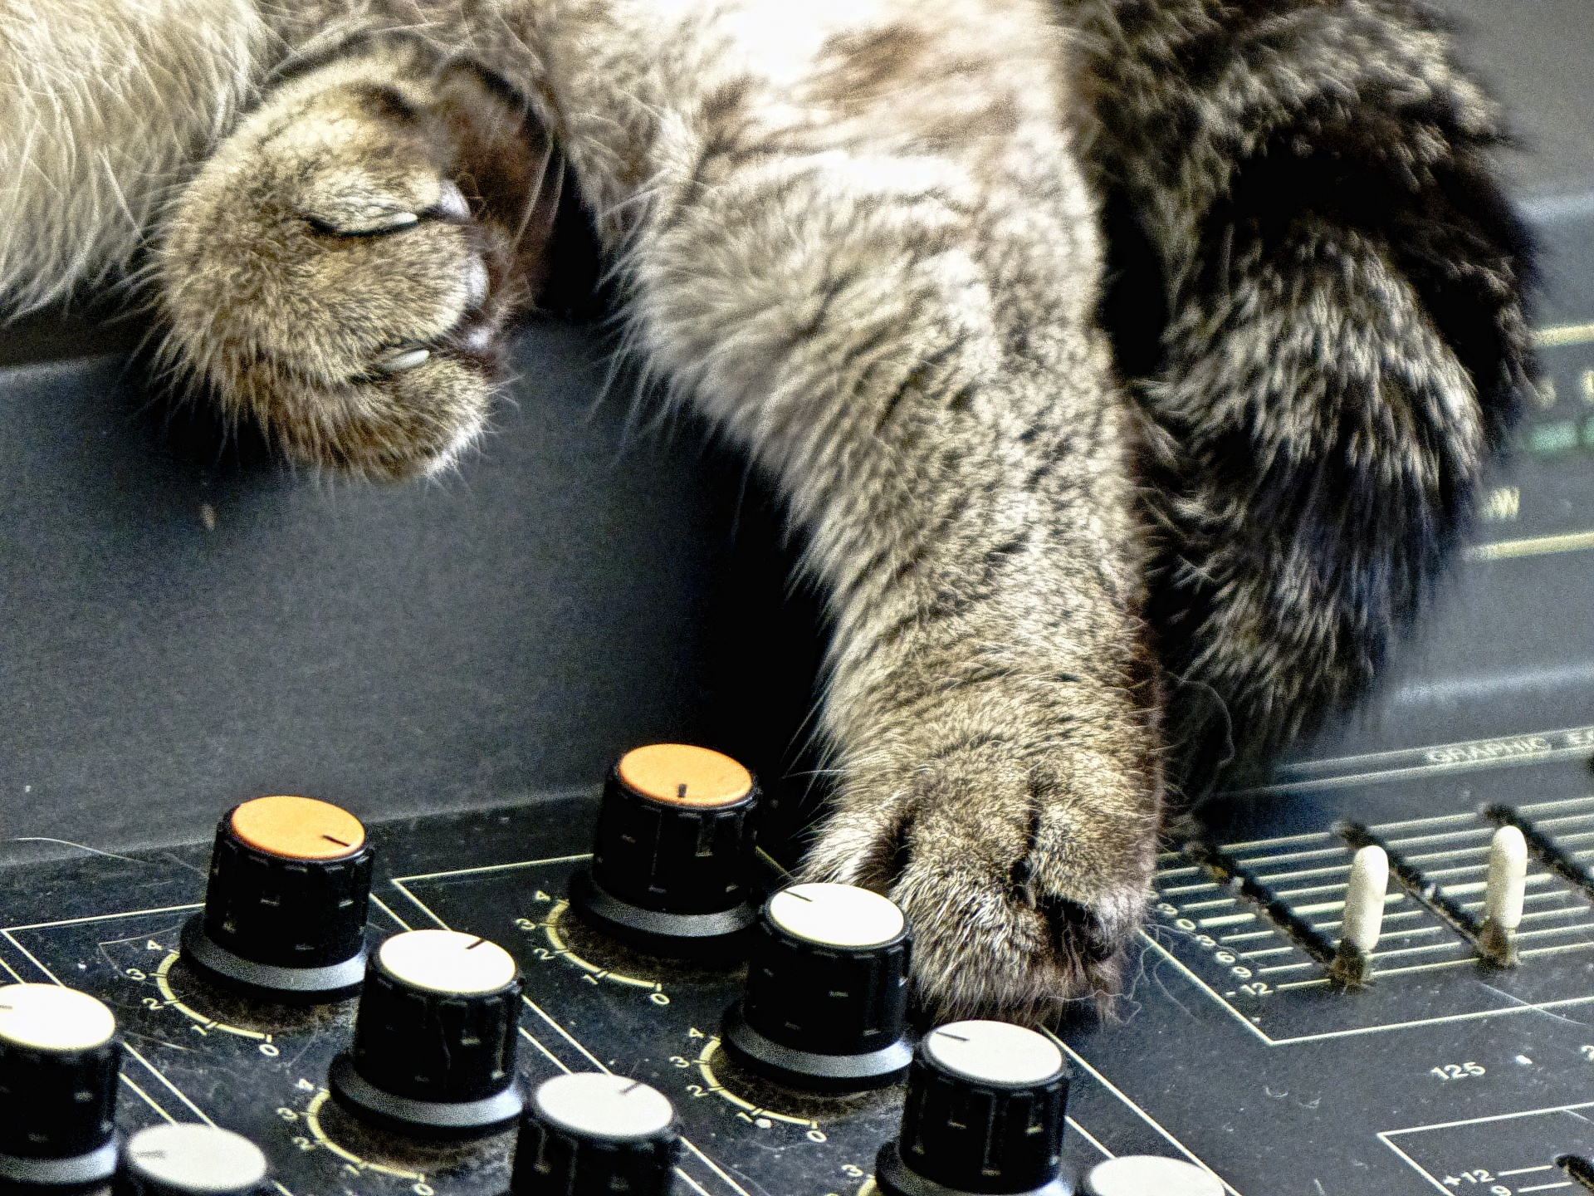

Unrelated, but the zine libraries interest group could use the signal boost. The Zine Librarians UnConference is in August. We are raising money to defray costs for zine librarians of color. Please share the [application](https://docs.google.com/a/barnard.edu/forms/d/e/1FAIpQLSf89kpBT0B8wM3_HlgmaZ2WHEsgBZTd5eLj-V1MALNRLdonwA/viewform) widely and PayPal VioletFox @ the goog if you can donate to the fund.

With affection and respect,

Jenna and the rest of the [ZineCat team](http://browse.zinecat.org/index.php/About/Index): Alex, Lauren, and Martí

# Message April 8, 2017

Dear You,

The Zine Union Catalog project has had a busy week, but we still don't have much to show for it. This is spring break week, so it may not be until April 20 or thereabouts that [our site](http://browse.zinecat.org/) really shows progress. We did add one visual element, though: our new logo, designed by Dafna Linden.

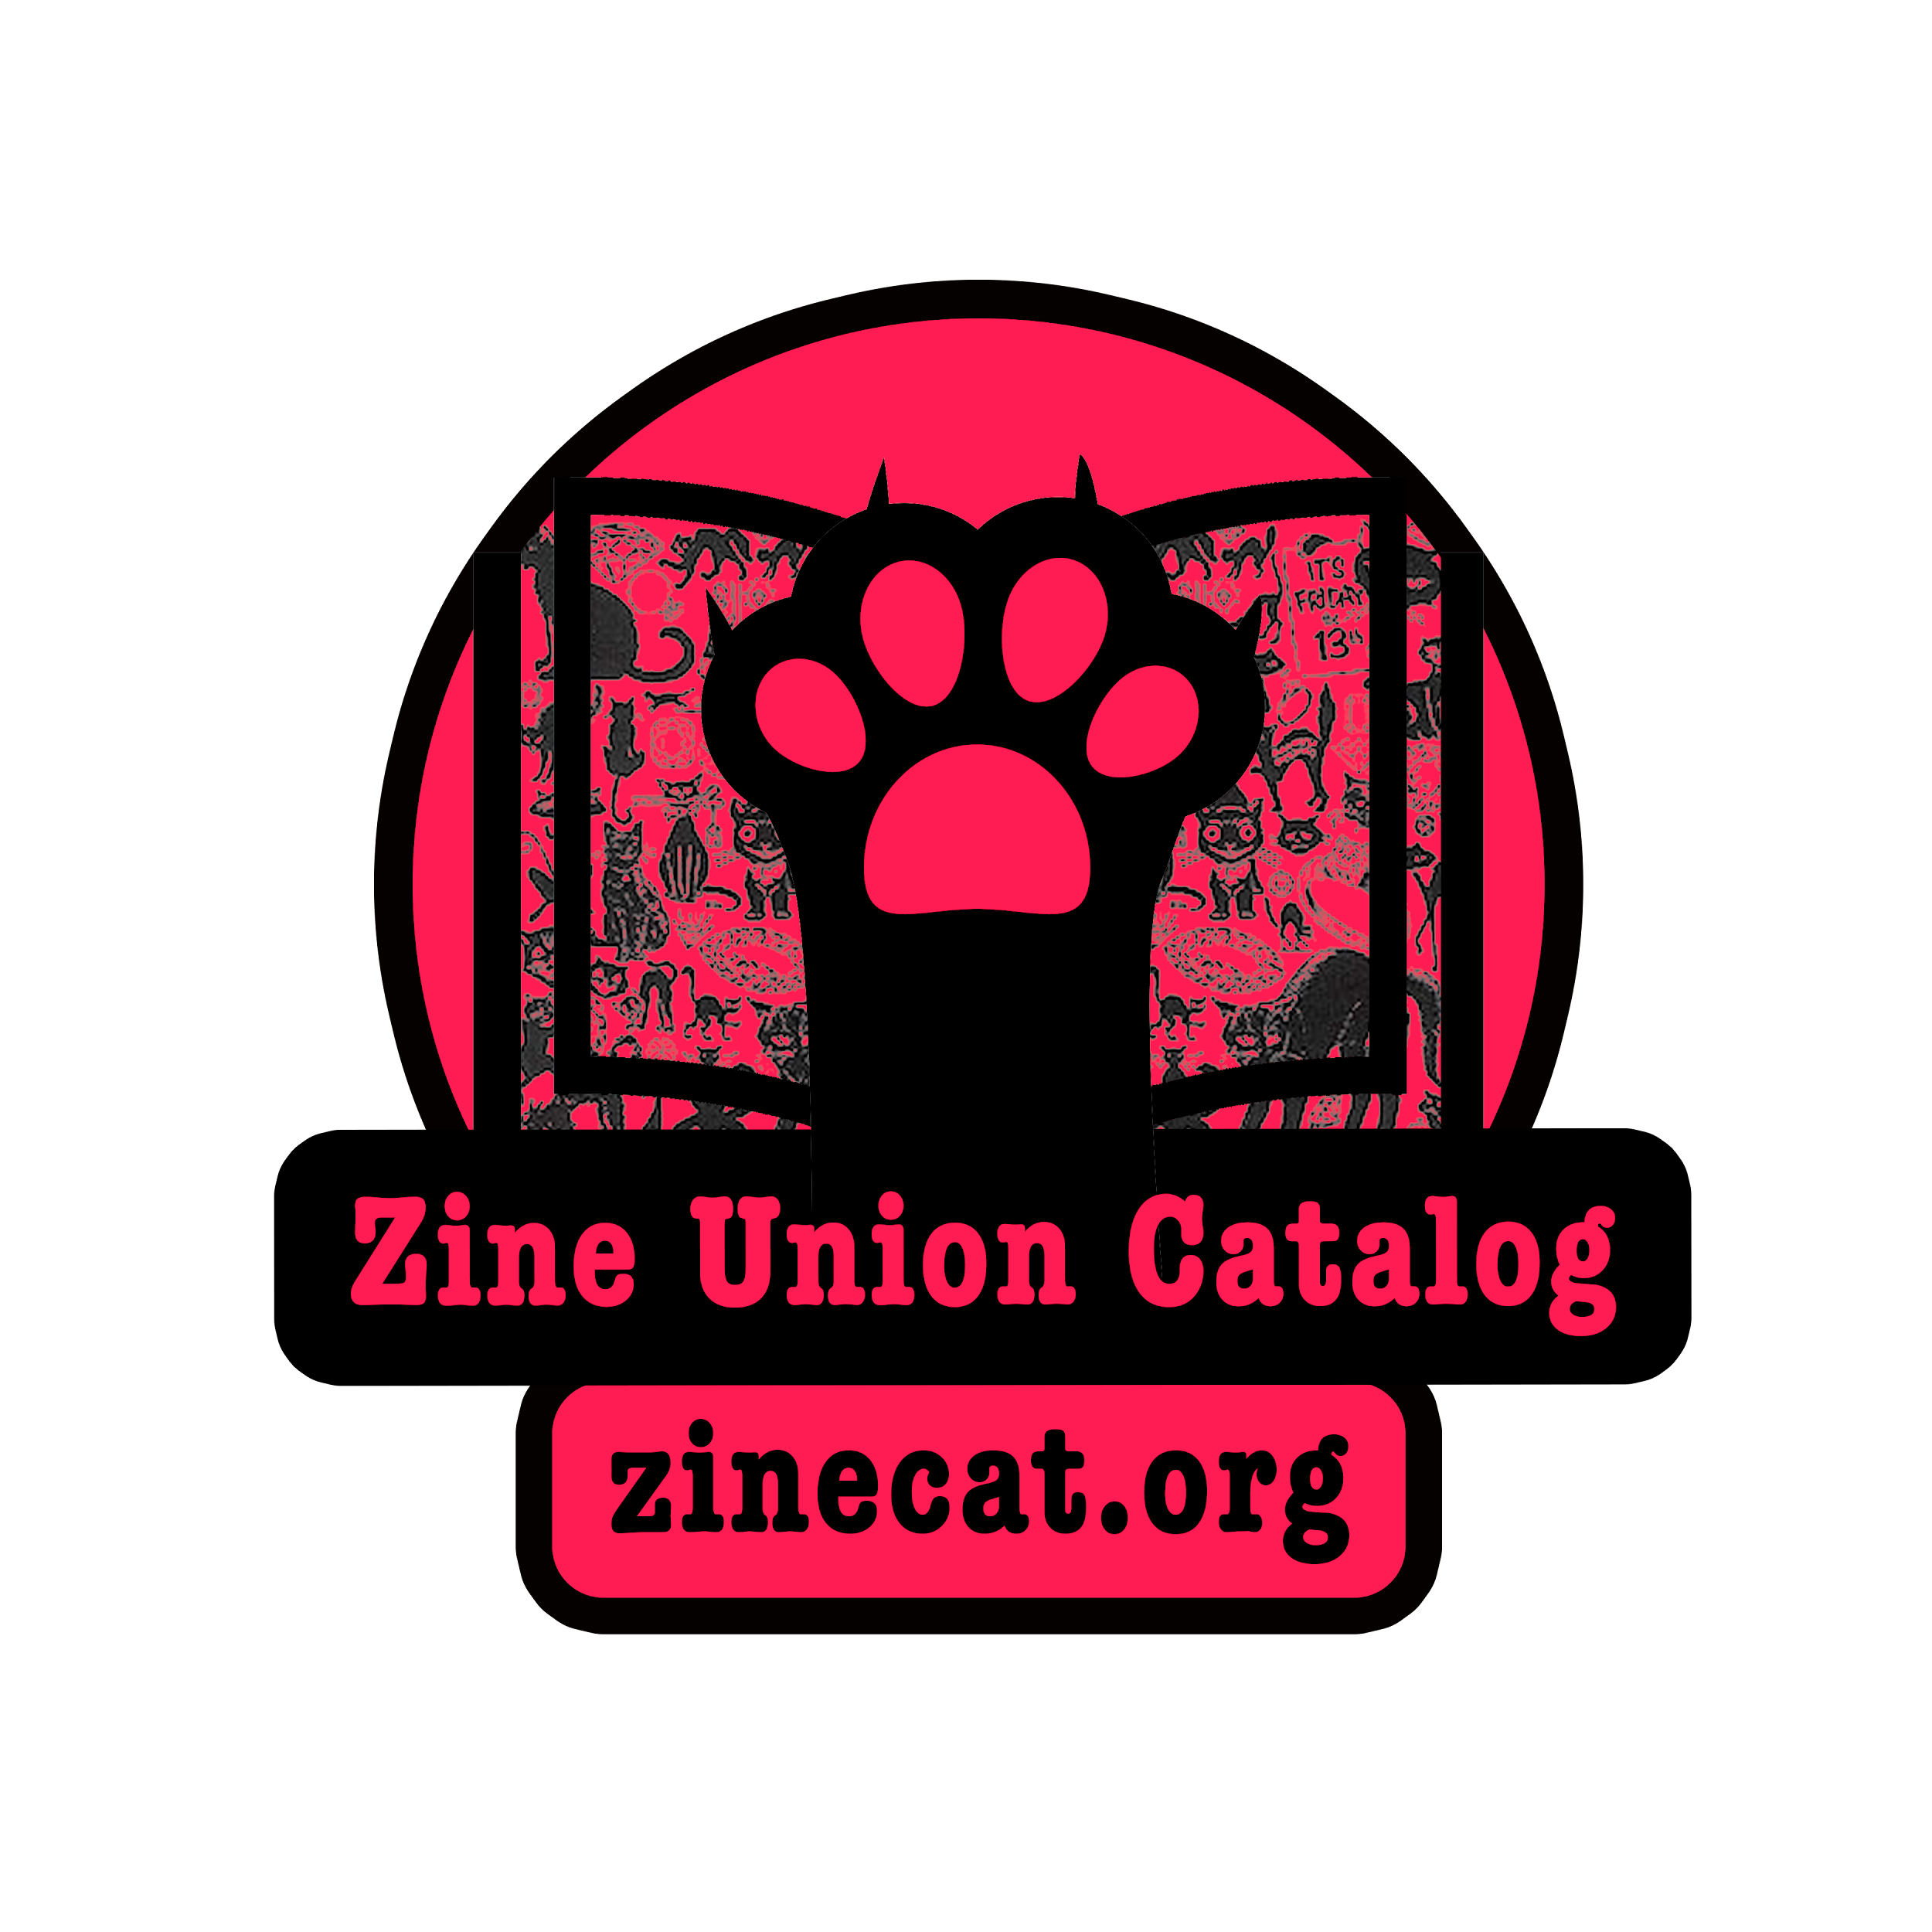

We'll have stickers for that soon and will be sure to send you one if you give me your postal address.

I'm copying the people who have given permission so far, but blind copying those who haven't. If you would like to opt in, please fill out this [easy form](https://docs.google.com/forms/d/e/1FAIpQLSeAy77fi_ZhaFCk9kxyAv8iw6gjqwJidhCbqHhzRO4b6JMVbg/viewform). Will you also give me any affiliation you're willing to share on the [advisory board blog post](http://blog.zinecat.org/updates/advisory-board/)?

Next week I'll give you more news about our plans for the rest of the semester and beyond (spoiler: NEH grant, assuming the NEH doesn't disappear in a puff of Cheeto dust).

With warmth and respect,

Jenna and the rest of the [ZineCat team](http://browse.zinecat.org/index.php/About/Index): Alex, Lauren, and Martí

# Message April 1, 2017

Dear You,

Thank you for agreeing to serve on the zine union catalog advisory board! We are grateful to have you on board and look forward to your contributions to our project. We thought a nice first step would be getting to know each other. Will you let us know if you willing for us to CC you on messages, vs. blind copying you as we did on this one? We would like to list and thank advisory board members on our website, we'll ask for your permission for that, too. Here's an [easy form](https://docs.google.com/forms/d/e/1FAIpQLSeAy77fi_ZhaFCk9kxyAv8iw6gjqwJidhCbqHhzRO4b6JMVbg/viewform) for letting us know your preference.

I do have a few updates to share. Feel free to give us feedback on any of the resources I report on.

Our catalog is installed on our adorably named website [zinecat.org](http://zinecat.org). We're working with a small subset of holdings from the [Queer Zine Archive Project](http://qzap.org), and trying to make them visible from the home page, with their metadata and without the blank thumbnail image. We've been getting help on our catalog installation with Advisory Board members Eric Goldhagen and Milo Miller. Thanks, Eric & Milo!

The zine catalog working group that pre-dates this project previously surveyed zine makers and zine librarians about how they'd use a zine union catalog. We now have a survey specifically for [zine scholars](https://docs.google.com/forms/d/e/1FAIpQLSfaCm9NlJSoIG94zxZdQYAO3mBbP1340bE_H8jp6_fbO_oBkw/viewform). Pass it on?

Until next week, with gratitude and respect,

Jenna and the rest of the [ZineCat team](http://browse.zinecat.org/index.php/About/Index): Alex, Lauren, and Martí

# Message March X, 2017

Dear Advisory Board Members,

Dear You,

Thank you for agreeing to serve on the zine union catalog advisory board! We are grateful to have you on board and look forward to your contributions to our project. We don't have anything for you to advise on yet, so I figured I'd let you know a little about us. Our bios are all on the [About page](http://browse.zinecat.org/index.php/About/Index) on our website. We are all in our first year at the CUNY Graduate Center Masters in Liberal Studies program. CUNY, the City University of New York, is all about education for The People, so I think it's a good home for a project about zines.

I do have a few updates to share. Feel free to give us feedback on any of the resources I report on.

Our catalog is installed on our adorably named website zinecat.org. We're working with a small subset of holdings from the [Queer Zine Archive Project](http://qzap.org), and trying to make them visible from the home page, with their metadata and without the blank thumbnail image. We've been getting help on our catalog installation with Advisory Board members Eric Goldhagen and Milo Miller. Thanks, Eric & Milo!

We're also working on design elements and hope to have promotional stickers to share with our beloved advisory board before too long.

The zine catalog working group that pre-dates this project previously surveyed zine makers and zine librarians about how they'd use a zine union catalog. We now have a survey specifically for [zine scholars](https://docs.google.com/forms/d/e/1FAIpQLSfaCm9NlJSoIG94zxZdQYAO3mBbP1340bE_H8jp6_fbO_oBkw/viewform). Pass it on?

Other places to follow our progress are our [blog](http://blog.zinecat.org/), [Facebook](https://www.facebook.com/ZineUnionCatalog/), and [Twitter](https://twitter.com/zinecat).

With affection and gratitude,

Jenna and the rest of the ZineCat team: Alex, Lauren, and Martí

# Sent Mid-March

Dear You,

For several years, a group of zine librarians from collections in public, community, and academic spaces in the US and Canada have been working toward building an online catalog where readers and researchers could search all of our zine collections at once--a zine union catalog (ZUC). This semester, a graduate school class on digital humanities decided to take the project on for the short-term, building a catalog prototype.

The zine librarians, as well as the [graduate students building the catalog](http://browse.zinecat.org/index.php/About/Index) (page content in progress), seek regular feedback from likely ZUC users, such as yourself--an advisory board. Would you be willing to try out our catalog every now and again over the next two months, preferably within 72 hours of our requests for feedback? We'll ask you one-three questions and allow for narrative responses, as well as answers on a scale or check boxes. We will be considerate of your time and expertise, and *extremely grateful* that you are willing to share them with us. Should the project generate any swag, you will be the first to get it.

With warmth and respect,

Jenna Freedman, Community Manager and the rest of the team:

Project Manager Martí Massana Ferre

Metadata Specialist and Documentarian Lauren Kehoe

Developer Alex Segal